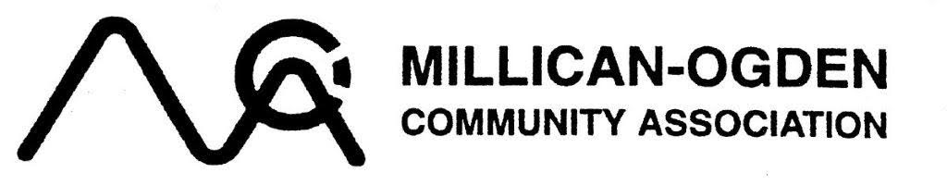

LEGO ENTRY FORM (Fill in and return to MOCA) $5.00 per entry (max 2 entries)

Builder’s name: _____________________________________ Date: _____________________________
Age: 2 – 5 Duplo/Lego ( ) 6 – 8 yr ( ) 9 – 12 yr ( ) 13 – 17 yr ( ) Adult ( )

Category: Buildings & Structures ( ) Vehicle & Transportation ( )
Animals & Figures ( ) Creative Invention ( )

Parent Name (if applicable): _______________________________ MOCA MBSP #: _____________________
Address: ___________________________________________________ Postal Code: _______________________
Phone: ____________________________ Email: _____________________________________________________
( ) Consent to receive emails
( ) Consent for photos - I hereby grant the Millican Ogden Community Association to take photos of myself/my child and Lego Creation and Lego creation for Marketing Purposes
( ) I have read, understand and accept the contest rules and information below
CONTEST INFORMATION AND RULES:
- Cost: $5.00 per entry (MAX. 2 entries per person) cash or cheque only.
- Make sure you enter into the correct age group.
- You will build your creation at home and bring it to the MOCA Hall. Limited space so register early.
- Entry forms are available in the office, newsletter and website: www.millicanogdencommunity.com
- No kits please! All entries must be original creations. No Bionicles.
- Entry forms due to MOCA office by: September 15th, 2023.
  - Mail or drop entry forms to: MOCA Office: 2110 69th Ave SE, Calgary, AB T2C 0R5 (cash or cheque)
- All Lego creations must be dropped off to MOCA Hall on Friday, September 29th, 2023 (6:00 – 8:00 pm)
- 1st, 2nd and 3rd Prize Ribbons & WIN Lego Kit Prizes! (based on availability)
  - Judging will take place by a group of local senior volunteers😊
- It’s FREE for all public to stop by and see all off the wonderful Lego creations on September 30th, 2023 between noon – 2:00 p.m.
- All Lego Creations must remain in contest until 2:00 p.m. on Saturday & picked-up 2:00 – 2:30 pm.

DISCLAIMER & RELEASE Millican Ogden Community Association MOCA is not responsible or liable for any lost, late, incomplete, invalid, corrupted, incorrectly addressed entries or any damage or loss arising from or connected with the contest. By participating in this contest, each participant hereby agrees to release and discharge MOCA and each of their directors, officers, members of their boards, employees, sponsors, prize suppliers and agents from all actions, claims and demands whatsoever arising directly or indirectly out of their participation in the Contest.

